 | CALIFORNIA STATE UNIVERSITY, LONG BEACH  BOB COLE CONSERVATORY OF MUSIC  MUSIC EDUCATION
LESSON PLAN REQUIREMENTS
Revised: 8/20/2013 Music Education, Cole Conservatory of Music
NAME: | Rudy Silva | CHECK  BELOW
SCHOOL: | High School | □Lesson Plan
GRADE/LEVEL: | 9-12/High School | ☒Rehearsal Plan
SUBJECT: | Music | Where in the UNIT does this occur?
I: | Wind Ensemble | □Beginning
C/V: |  | ☒Middle
OTHER: |  | □End
Terminal Objective:
What do you expect your students to be able to do by the end of the lesson/rehearsal, day, or unit?
How does this objective promote your overall curriculum?
- Students will be able to determine how the lyrics of “My Bonny Boy” are evoked in the music of second movement of English Folk Song Suite by Ralph Vaughan Williams.
- Students will be able to compare and contrast the effectiveness of tempos, intonation, tone quality, style, dynamics, and phrasing of two exemplary recordings of English Folk Song Suite and make informed judgments to determine which of the two is preferred.
- Students will be able to understand that English Folk Song Suite is played using different interpretations by different ensembles.
- These objectives promote my overall curriculum because it will help them understand stylistic interpretations of music.
Prior Knowledge: Consider your timeline above.
What skills can they already demonstrate?
What previous knowledge do you assume they understand?
The students have already learned how to play with good balance and intonation within a wind band ensemble setting.
Standards to be addressed with corresponding objectives.
Write out each standard with each objective immediately following.
4.4 Describe the means used to create images or evoke feelings and emotions in musical works from various cultures.4
4.1 Develop specific criteria for making informed critical evaluations of the quality and effectiveness of performances, compositions, arrangements, and improvisations and apply those criteria in personal participation in music.
4.2 Evaluate a performance, composition, arrangement, or improvisation by comparing each with an exemplary model.

Materials:
List all materials needed by both students and teacher.
- Computer
- Sound System/Speakers
- Worksheet
Anticipatory Set/Introduction/Pretest: How will you grab students’ attention?
What activity will you do to test whether or not they already know or can demonstrate what you plan to teach in this lesson?
The teacher will display a PowerPoint presentation that begins with a display of the lyrics from the English folksong, “My Bonny Boy,” which is used in the melody of the second movement of Ralph Vaughan Williams’ English Folk Song Suite. The teacher will select certain students to read parts of the lyrics to promote student engagement. The teacher will be careful to select female students to read, as to not make certain parts of the text uncomfortable for a male student to read (for example, “I once loved a boy...”).
Procedures/Development/Timeline:
Script the lesson step-by-step and state how you will check for understanding
Include T: (teacher) / S: (student) what will be demonstrated or spoken.
Include a timeline to show you have considered how much time each activity will take.
Time | Teacher | Student
5:00 | The teacher will ask the students to think of how the recordings they are about to listen to evoke and promote the lyrics of the folksong they just read/listened to. The teacher will then play the first recording of English Folk Song Suite of Jerry Jenkins’ ensemble. | The students will record their comments on their worksheets in pairs.
0:30 | The teacher will inform the students that the next recording uses different instrumentation (orchestra version) and will instruct them to listen to how the instrumentation can promote the lyrics. | The students will listen attentively to the teacher.
3:00 | The teacher will then play the second recording of English Folk Song Suite. | The students will record their comments and compare/contrast the two recordings.
5:00 | The teacher will ask a few groups to share their responses. | The students will share their opinions of what they heard in both recordings.
1:00 | The teacher will inform the students that this piece is played frequently using many different stylistic interpretations, as was observed in this listening lesson. | The students will listen attentively and ask the teacher questions for any clarifications.

Practice (Guided, manual assistance, etc):
Describe how the students will practice the new skill with/without you.
The students will complete the worksheet in pairs to determine which recording they prefer.
Accommodations (Special Needs/EL):
What lesson accommodations will you make/from whom will you seek advice?
The PowerPoint incorporates images to help EL students comprehend the lyrics of the folksong. In addition, the teacher will walk around the classroom as the students are completing the worksheet and will provide one-on-one assistance to special needs and EL students. In addition, the worksheet has graphic images incorporated to assist these students with the terminology needed to complete the assignment.
Assessment:
The assessment must measure what you stated as your intended standards/objectives above. Explain how you will monitor
and record assessment of this lesson.
The teacher will walk around and ensure that the students are completing the worksheet. In addition, the students will be turning in the worksheet for the teacher to review and make written comments.
Closure:
Students should be able to identify the most important elements of the lesson.
How will you teach for transfer?
How will the students do this?
The students will be able to make an informed decision as a group as to how they would like to perform the piece in future rehearsals.

Names______________________________________________________________________

Wind Ensemble Worksheet
English Folk Song Suite (Ralph Vaughan Williams)
Second Movement, Intermezzo

How are the lyrics of “My Bonny Boy” evoked through the first section? Think of major/minor, texture, instrumentation, registers, etc. Which of the two recordings was more effective?

Compare/Contrast Listening Activity:
Listen to the recordings of English Folk Song Suite and write down your observations below:

Recording 1:
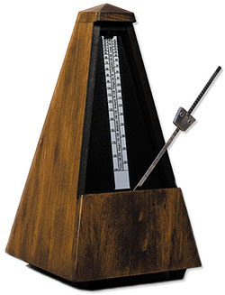
Tempos:
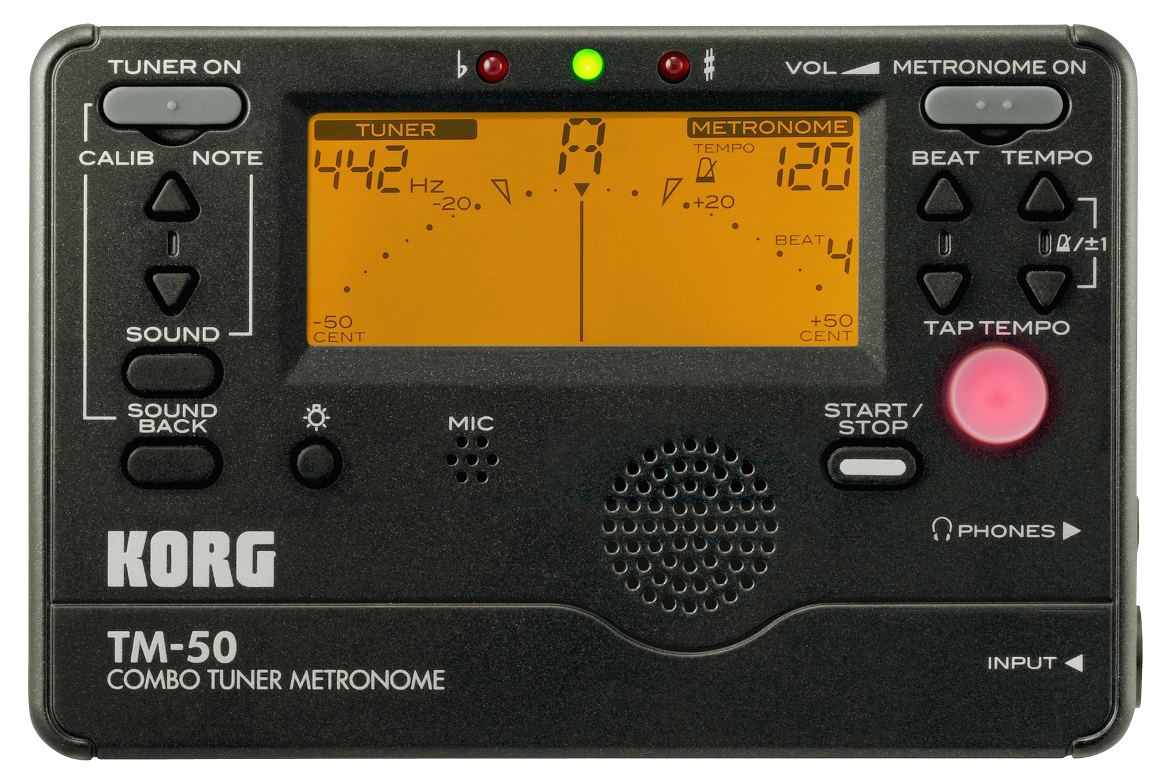
Intonation (do they play in tune?):
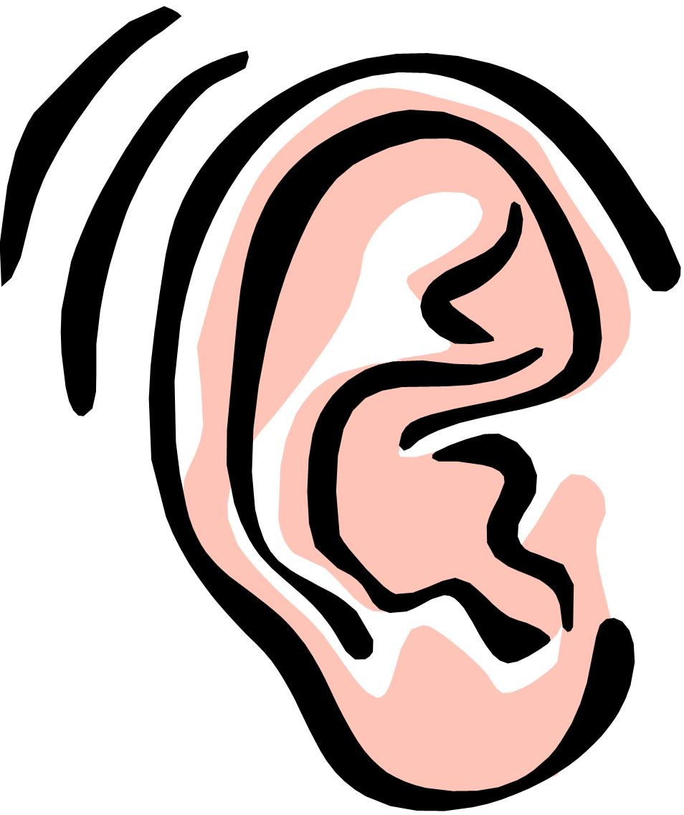
Tone quality:
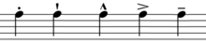
Style (are they playing fluid-like? What about the Scherzando section, how do they execute style?):


Effectiveness of dynamics:
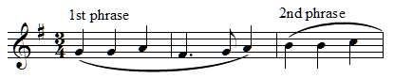
Phrasing (are phrases long, short, connected?):

Recording 2:
Tempos:
Intonation (do they play in tune?):
Tone quality:

Style (are they playing fluid-like? What about the Scherzando section, how do they execute style?):

Effectiveness of dynamics:

Phrasing (are phrases long, short, connected?):

