Lesson Plan: B-D-A Lesson
Your Name: Rudy Silva Date: Tuesday, November 26, 2013
Grade Level: 10th Grade Subject: Music/Concert Band
Objectives and Goals:
Standards (CCSS/NGSS/California Content Standards):
California Music Content Standard #1.3: Sight-read music accurately and expressively (level of difficulty: 3 on a scale of 1-6).
California Music Content Standard #1.4 Analyze and describe the use of musical elements and expressive devices (e.g., articulation, dynamic markings) in aural examples in a varied repertoire of music representing diverse genres, styles, and cultures.
California Music Content Standard #2.4 Perform on an instrument a repertoire of instrumental literature representing various genres, styles, and cultures with expression, technical accuracy, tone quality, and articulation, by oneself and in ensembles (level of difficulty: 4 on a scale of 1-6).
California Music Content Standard #2.5 Perform on an instrument in small ensembles, with one performer for each part.
California Music Content Standard #4.2 Evaluate a performance, composition, arrangement, or improvisation by comparing each with an exemplary model.

Content Objective:
- The students will be able to analyze The Witch and the Saint by Steven Reineke before sight-reading to become aware of musical elements incorporated into the piece for a successful first-time performance.
- The students will be able to sight-read The Witch and the Saint, a musical selection written by Steven Reineke, in groups of three with expression, proficient technical accuracy, good tone, and with the indicated articulations with at least 80% accuracy and will remember where they make errors as they sight-read to later correct.
- The students will be able to describe musical elements and styles utilized in The Witch and the Saint after they listen to a professional recording of the work.
- The students will be able to evaluate their own performance of The Witch and the Saint after they sight-read and listen to a professional recoding of the piece to use as an exemplary model.

Language Objective:
- The students will complete a graphic organizer to analyze The Witch and the Saint to prepare them for sight-reading by identifying key signatures, time signatures, accidentals, difficult rhythms, signs, dynamics, and articulations.
- The students will collaborate in groups of three to sight-read The Witch and the Saint and will engage in discussion afterward to provide their peers with concrete strategies on how to improve their sight-reading skills.
- The students will complete a T chart describing in words on one side the musical elements they successfully executed during sight-reading and on the other side musical elements they did not play or that they could improve on. The students will share their T chart with their group.
- The students will complete a flow map graphic organizer to analyze and describe using words how The Witch and the Saint develops from beginning to end in terms of style, articulations, and mood.
- The students will read a brief text describing the program information for The Witch and the Saint, its meaning and intent for composition, and they will complete a 3-2-1 list outlining 3 pieces of information they found important in the storyline, 2 elements they found interesting, and 1 element that they think will contribute to their personal connection between the storyline and their performance of the piece.
Required Materials and Equipment:
The Witch and the Saint individual band parts and conductor’s score
Students will have their own instruments
Anticipation Graphic Organizer
T chart handouts
MP3 player and recording of The Witch and the Saint
Flow map graphic organizer handouts
Handout of program notes for The Witch and the Saint
White board and dry-erase markers
Blank sheets of paper, in case students do not have writing paper
Guiding Question(s):
Did you know that some music was composed with intent to convey people, a storyline, or idea?
Do you think your performance of music could be a different experience if you knew a piece had an emotion or story attributed to it?
Vocabulary necessary for instruction:
Programmatic tone poem, expression
Objective as stated to students before lesson:
Today, you will be sight-reading a new piece called The Witch and the Saint. You will sight-read in assigned groups of three. Afterward, you will listen to a professional recording and will compare your performance to the recording and have the opportunity to share with your group how to improve your performance. We will then learn about the piece, why it was written and what musical elements we can find in it and you will be able to write what you learned about the piece.
Anticipatory Set:  As the students walk into the classroom, they will notice that the teacher has written on the board: “Sight-reading day! The Witch and the Saint.” The board will also instruct the students to sit in assigned groups of three. The groups and each group member’s names will be written on the board. The teacher will have the Anticipation graphic organizer, T chart, flow chart, and program note handouts already on their music stands. | Rationale:  When the students read the board, they will instantly know that this lesson is one that will require focus on their part. They should also feel some comfort knowing that they will not be sight-reading on their own but that they will be collaborating in groups of three. Seeing the handouts on their stands might also build some curiosity as to the nature of the activities that the teacher has planned for this lesson.
Direct Instruction/Modeling/Guided Practice:  - The teacher will hand out the music to each group at the start of class. The teacher will ask that the students keep their music face down until told to turn it over.  - The teacher will ask the students to complete their Anticipation organizer. This organizer utilizes the mnemonic: STARS. (Sharps/flats, Tempo, Accidentals, Rhythms, and Signs/style). The teacher will instruct the students to analyze The Witch and the Saint and write down key components of the music before they begin sight-reading the piece. The teacher will ask the students to identify: key signatures, time signatures, accidentals, difficult rhythms, signs, dynamics, and articulations.  - The teacher will select one group at a time to sight-read important sections of the music. The teacher will select two short contrasting sections of the piece for each group to sight-read for the rest of the class and will ensure to allow for all groups to sight-read. The teacher will ask the students to remember where they have made mistakes as they sight-read.  - After sight-reading, the teacher will ask the students to take out the T chart that was placed on their stands. The teacher will play a professional recording of The Witch and the Saint. The teacher will ask the students to fill out the T chart as they hear the sections they sight-read. The teacher will also explain the term expression.  - At the end of the lesson, the teacher will ask the students to read the program notes that are on their stand. The teacher will explain what the term programmatic tone poem means. | Rationale:  - In order to properly assess student’s comprehension of musical knowledge to accurately sight-read, the students should not be given the opportunity to discuss what they are about to sight-read with their partners.  - Having the students complete a graphic organizer to analyze the music will ensure that they are mentally prepared and aware of the elements that are embedded into the music and will lessen their chances of missing accidentals, rhythms, and articulations. This activity will be differentiated for three levels of ELD students. For a Beginning level student, this activity will be adapted by providing the student with further teacher and/or peer assistance in pointing out the key elements of the piece. The teacher will also refer to the organizer and point to elements in the music to make connections with vocabulary (such as key signature, rhythms, articulations). For an intermediate level student, the teacher will ask the student to verbally respond to the questions on the organizer. For an advanced level student, the student will be asked to complete the organizer with the help of his or her partner.  - By having each group sight-read two contrasting sections, the teacher can assess comprehension of note reading, articulations, expressive elements, and style changes. A beginning level student will be instructed to point to the errors they make when they finish. The teacher will also assist the student by pointing errors out using the music. An intermediate student will be asked to identify his or her errors verbally and the teacher will assist by asking questions such as “did you play everything you see on the page from measures 1-10?” An advanced student will be asked to share with his partner what he missed, and the partner will assist the student.  - By having the students listen to an exemplary model of the piece they just sight-read, they can check their comprehension of the music and determine what they did well and what they need to improve. Having them fill out the T chart while they listen to the recording will also keep the students engaged. For a beginning student, the T-graph will be scaffolded by including pictures of elements embedded in the piece. The pictures will assist the student in determining what they executed correctly and what they could improve. The teacher will provide assistance in filling out the T-chart. For the intermediate student, the student will collaborate with their partner to receive assistance with completing their T chart. The teacher will monitor student progress and offer assistance, if needed. For the advanced student, the student will share their written answers with their partner.  - Having the students read the program notes for the piece will give them an opportunity to make a connection to the music. It will also enhance their comprehension of the work and the composer’s intention for writing the piece. Beginning and intermediate students will be read to by their partners. Advanced students will read on their own and have the ability to get assistance from the teacher or partner if needed.
Independent Practice:  - The students will share with their group members what they wrote on their T charts and will also have the opportunity to critique each group member’s performance.  - The students will collaborate in their groups and will complete a flow chart describing the sequence of the piece, including how articulations, style, technicality, and mood of the piece develop.  - After the teacher has taught the students the term programmatic piece, the students will read the program notes for the piece and will complete a 3-2-1 list. They will use their own piece of paper to respond to 3 pieces of information they found important in the storyline, 2 elements they found interesting, and 1 element that they think will contribute to their personal connection between the storyline and their performance of the piece. | Rationale:  - By having the students collaborate with their group members, they can gain knowledge from each other on how to improve. It will also help them develop critiquing skills as well as their listening skills. Beginning ELL students will be encouraged to use pointing to the music to relate to their partners what they accomplished well and what they need to improve on. Intermediate students will be asked questions by their partners to assist them in providing answers, such as “what did you think about the way you played that difficult rhythm?” Advanced students should be able to discuss their answers with some assistance from their partners.  - By having the students fill out a flow chart, the teacher can assess the student’s comprehension of the piece and check for understanding of stylistic and expressive elements found in the piece. Beginning students will be given a partially completed flow chart. The student can also draw pictures to describe the elements. The teacher will check for the student’s progress and assist the student. Intermediate students will also be allowed to draw pictures and use short phrases to describe the elements. Advanced students will complete the chart and collaborate with their partner for assistance.  - The teacher can ensure that the students comprehend both the musical text and the programmatic text. This activity will also develop in the students a personal connection to the music. Knowing the storyline might attribute an emotional connection and thus provide for a more aesthetical performance. Beginning students can draw images that describe the storyline and collaborate with their partners to have the story read to them. Intermediate students will be read to by their partners and will collaborate with their partners to determine the key points of the program. Advanced students will be encouraged to use a highlighter to highlight important elements of the story and copy the sentences on their worksheet.
Assessment and Follow-Up/Next Steps:  The students will be turning in their anticipation graphic organizer, T chart, flow maps, and 3-2-1 lists. The teacher will read their work and will make written comments evaluating their critique and comprehension of the musical and programmatic texts. | Rationale:  This is a formative assessment, and by providing written comments, the students will have the information necessary to know how to improve their performance of the piece and the students will know if they have misunderstood any part of the program notes. The teacher will also be able to make any modifications to future lessons. As an example, if students have difficulties with any rhythmic examples from the piece, the teacher can focus on rhythmic issues in the piece.
Transition to following topic:  The following lesson will involve performing The Witch and the Saint as a whole concert band ensemble. The students will be given opportunities to improve their performance within a bigger ensemble setting. | Rationale:  The students will have determined how to improve their performance as individual performers. The next step would be to improve as an ensemble performer, which would lead to topics of intonation, balance and blend, and tempo precision. The sight-reading has functioned as a foundation for these next topics.
Notes:
Ensure that the students are aware that the program content of the piece is in no reference to sorcery or witchcraft. Some students might be concerned, or it may also lead to parental concern.

Mr. Silva
Concert Band
Fall 2013

Name_______________________________________ Date______________________

Instrument_____________________________________

Anticipation Organizer Sight-Reading
The Witch and the Saint, by Steve Reineke

Before you sight-read, preview the music and identify the following to help prepare you to look ahead and successfully play the music for the first time. Write in the stars provided and provide measure numbers.

Tempo/Time Signature

Sharps/Flats
b n m
Accidentals

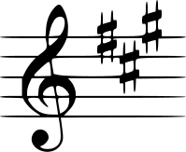

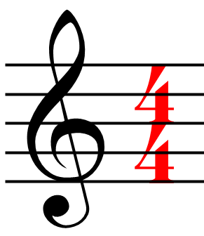

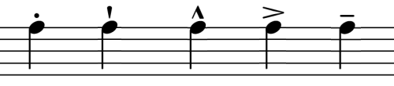

Signs/Style
Rhythms

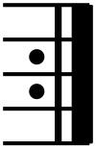
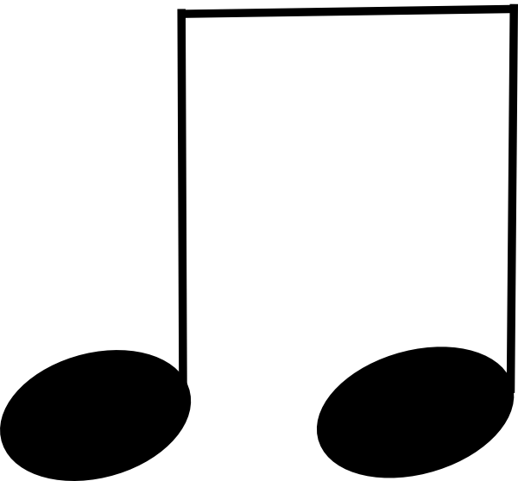

Adapted from: http://flmusiced.org/FLmusicApps/Sessions/Handouts/2012/STARS
sightreadingguide.pdf

Mr. Silva
Concert Band
Fall 2013

Name_______________________________________ Date______________________

Instrument_____________________________________

T Chart Organizer - Sight-Reading
The Witch and the Saint, by Steve Reineke

After you have sight-read The Witch and the Saint, you will listen to a professional performance recording of the piece. As you listen, compare your sight-reading sections to the recording and write in your own words what you did well and what you could have done better. Consider: rhythmic accuracy, technical accuracy, tone quality, dynamic contrast, articulations, and stylistic interpretation.

What I Did Well | What I Could Have Done Better
Mr. Silva
Concert Band
Fall 2013

Name_______________________________________ Date______________________

Instrument_____________________________________

T Chart Organizer (Scaffolded) - Sight-Reading
The Witch and the Saint, by Steve Reineke

After you have sight-read The Witch and the Saint, you will listen to a professional performance recording of the piece. As you listen, compare your sight-reading sections to the recording and write in your own words what you did well and what you could have done better. Consider: rhythmic accuracy, technical accuracy, tone quality, dynamic contrast, articulations, and stylistic interpretation.

What I Did Well | What I Could Have Done Better
I played using the correct time signature  Yes____ No ____  I played most of the rhythms correctly  Yes___ No___  I played the accidentals.  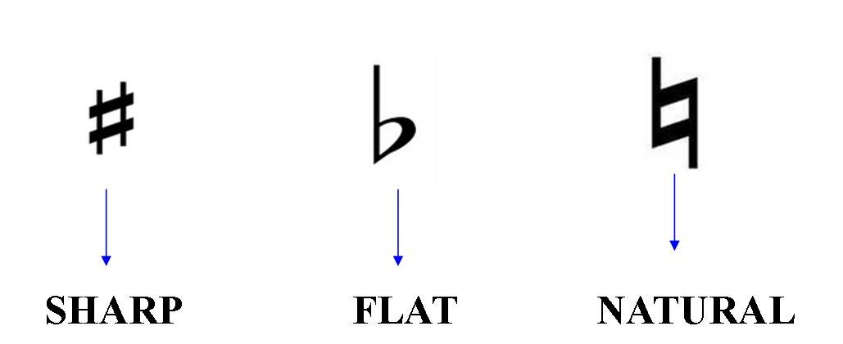 Yes____ No____  My tempo was appropriate for sight-reading  Yes ___ No____  I played using good tone.  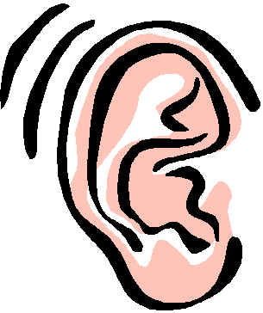 Yes____ No____ | I could have identified the correct time signature better  Yes____ No ____  I played more of the rhythms correctly  Yes___ No___  I missed too many accidentals.  Yes____ No____  My tempo was not appropriate for sight-reading  Yes ___ No____  I could have played with better tone.  Yes____ No____

Mr. Silva
Concert Band
Fall 2013

Name_______________________________________ Date______________________

Instrument_____________________________________

Flow Map Organizer
The Witch and the Saint, by Steve Reineke

After you have listened to a recording of The Witch and the Saint, fill out this flow map to describe the piece as it progresses from beginning to end. You can describe the mood, articulations, rhythms, instrumentation, and styles of each section. You can use your own music to complete this organizer.

Beginning

Middle

End

Mr. Silva
Concert Band
Fall 2013

Name_______________________________________ Date______________________

Instrument_____________________________________

Read the following program notes that describe the story behind The Witch and the Saint. After you have read the program notes, write down:
- 3 important points that summarize the program notes
- 2 points you find interesting
- 1 point you can use to help you better perform the piece or that you personally connect with.

“The Witch and the Saint is a programmatic tone poem for symphonic band and is constructed of five distinct sections. The opening depicts the birth of twin sisters born in 1588 in Ellwangen, Germany. In those times, the birth of twins was considered a bad omen and as the sisters grew up, it became clear that they had the gift of second sight and could predict future events. The thematic material representing both sisters is first introduced in this section along with a medieval Gregorian chant-type motif. The second section is the development of Sibylla’s theme. This sister led a horrible life and her gift was looked down upon. Many townspeople feared Sibylla and considered her to be a witch. After a brief transition, the theme representing the other sister, Helena, is introduced in its entirety. The third section is the development of Helena’s theme. This sister was sent away to a convent when she was a child. While at the convent, Helena is revered as a saint because of her visions. The forth section is a turbulent section representing the struggle both sisters had in their lives. Eventually, Sibylla is imprisoned and Helena returns to the town to save her sister. The fifth section and finale of the piece depicts the return of Helena and the rescue of her sister, Sibylla. As they are trying to escape, the sisters are captured once again, and this time, for fear of being burnt at the stake, the saint, Helena, drinks some poison. She dies in her sisters arms and Sibylla, the witch, rides off in sorrow.”

Source: The Anchor Bay High School Instrumental Music Department
http://www.anchorbaybands.org/documents/hs/concertprograms/WinterProgram
(12.06.06).pdf

